Project Design Phase-III
Technology Stack (Architecture & Stack)

Date: | 18 FEB 2026
Team ID: | LTVIP2026TMIDS54469
Project Name: | Visualizing Housing Market Trends: An Analysis of Sale Prices and Features using Tableau.
Maximum Marks: | 4 Marks

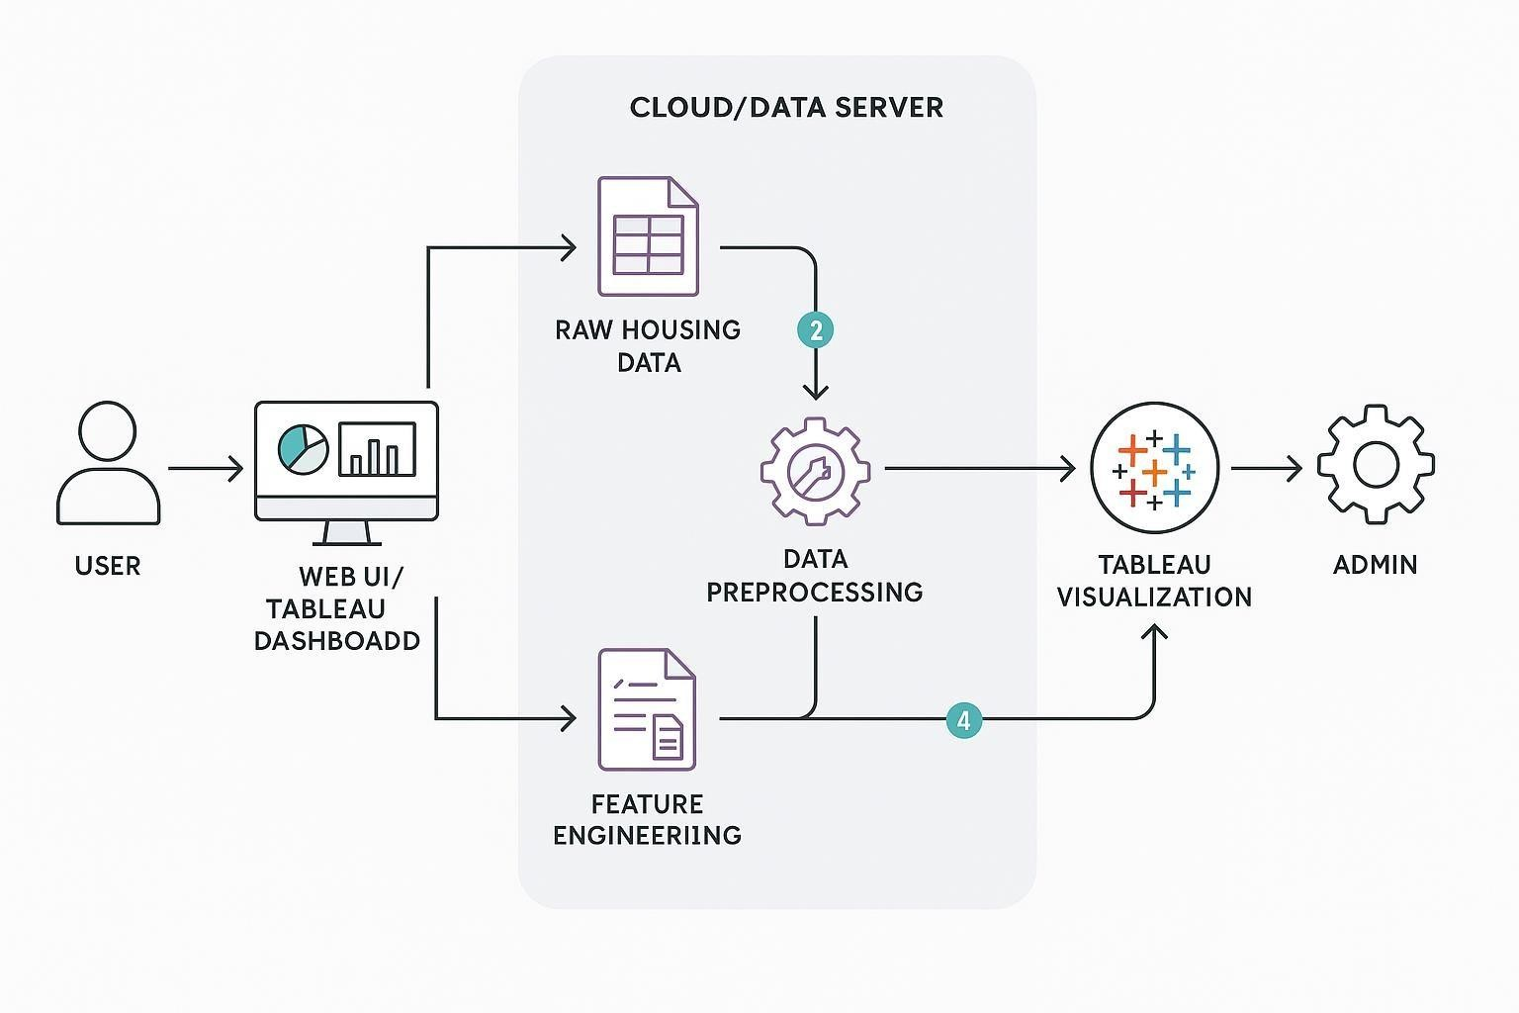
Technical Architecture:
This project leverages data visualization to analyze housing market trends such as sale prices and housing features using Tableau. It focuses on visual exploration rather than complex machine learning or cloud-native deployments. The architecture is primarily local with support from lightweight scripting and desktop-based tools.
Architecture Diagram Summary:
- • User Interface (Tableau Dashboard) - Users interact with visualizations.
- • Data Source (Local File Storage) - CSV or Excel files used as input.
- • Preprocessing (Python) - Data is cleaned and structured using pandas.
- • Feature Engineering (Python or Tableau Prep) - Additional insights generated.
- • Visualization Layer (Tableau Desktop / Public) - Interactive dashboards built and published.
- • Infrastructure - Local machine for development and deployment.

Table-1: Components & Technologies:
S. No | Component | Description | Technology Used
1 | User Interface | Dashboard  interface for user interaction | Tableau Public / Tableau Desktop
2 | Application Logic-1 | Preprocessing logic for housing data | Python (Pandas,  NumPy)
3 | Application Logic-2 | Feature engineering and transformations | Tableau Prep / Python
4 | Application Logic-3 | Not used | Not Used
5 | Database | Raw data storage  (optional, using files) | Not Used / CSV
6 | Cloud Database | Not used in this project | Not Used
7 | File Storage | For storing CSV/Excel input  files | Local Filesystem
8 | External API-1 | Not used | Not Used
9 | External API-2 | Not used | Not Used
10 | Machine Learning Model | Not used | Not Used
11 | Infrastructure | System where the application runs | Local Desktop (Windows/Mac)

Table-2: Application Characteristics:
S. No | Characteristics | Description | Technology
1 | Open-Source Frameworks | Data preprocessing and manipulation | Python (Pandas,  NumPy)
2 | Security  Implementations | No user authentication or cloud data access in current version | Not Applicable
3 | Scalable  Architecture | Not designed for cloud scale or multiple users | Not Applicable
4 | Availability | Local system availability only | Tableau Desktop on personal system
5 | Performance | Handles small to medium datasets, processed locally using efficient libraries | Python (Pandas),  Tableau  Optimizations

